Determiner Function

🔹 What is Determiner Function
# Source: AI Source: Provided by: [Data Path: Persons Table -> ID Column: 1, Name_En Column: Motasem Essam] -> From: [Chatgpt (GPT-4-turbo)] on [8/3/2025]
The determiner function refers to the grammatical role played by determiners in a noun phrase.
A determiner is a word that appears before a noun and introduces or limits it, helping to show which, whose, how many, or what kind of noun is being referred to.
🧠 In terms of grammatical function, a determiner modifies a noun to indicate reference, quantity, or definiteness.

✅ Role in Sentence Structure:
# Source: AI Source: Provided by: [Data Path: Persons Table -> ID Column: 1, Name_En Column: Motasem Essam] -> From: [Chatgpt (GPT-4-turbo)] on [8/3/2025]
- Determiners function as modifiers in noun phrases.
- They appear before adjectives and the head noun.
- They do not stand alone — always part of a noun phrase.
➤ Basic Pattern:
Determiner + (Adjective) + Noun
Example:
- That old house is haunted.
→ “That” is the determiner modifying “house.”

✅ Main Classes of Determiners (by Function):
# Source: AI Source: Provided by: [Data Path: Persons Table -> ID Column: 1, Name_En Column: Motasem Essam] -> From: [Chatgpt (GPT-4-turbo)] on [8/3/2025]
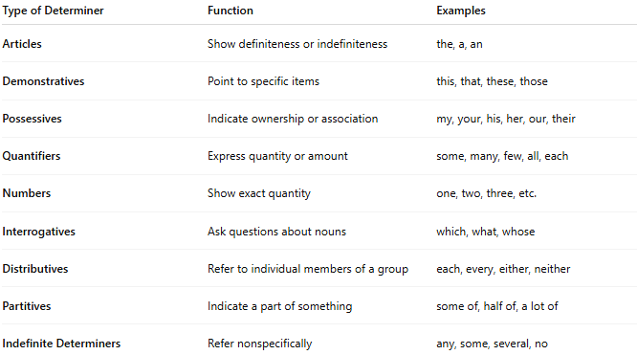
Type of Determiner | Function | Examples
Articles | Show definiteness or indefiniteness | the, a, an
Demonstratives | Point to specific items | this, that, these, those
Possessives | Indicate ownership or association | my, your, his, her, our, their
Quantifiers | Express quantity or amount | some, many, few, all, each
Numbers | Show exact quantity | one, two, three, etc.
Interrogatives | Ask questions about nouns | which, what, whose
Distributives | Refer to individual members of a group | each, every, either, neither
Partitives | Indicate a part of something | some of, half of, a lot of
Indefinite Determiners | Refer nonspecifically | any, some, several, no

✅ Examples in Sentences:
# Source: AI Source: Provided by: [Data Path: Persons Table -> ID Column: 1, Name_En Column: Motasem Essam] -> From: [Chatgpt (GPT-4-turbo)] on [8/3/2025]
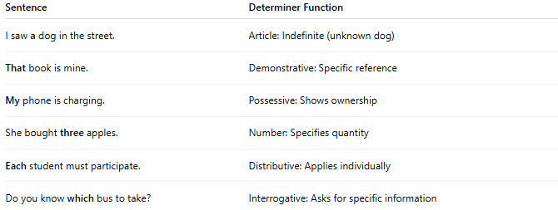
Sentence | Determiner Function
I saw a dog in the street. | Article: Indefinite (unknown dog)
That book is mine. | Demonstrative: Specific reference
My phone is charging. | Possessive: Shows ownership
She bought three apples. | Number: Specifies quantity
Each student must participate. | Distributive: Applies individually
Do you know which bus to take? | Interrogative: Asks for specific information

✅ Position in Noun Phrase:
# Source: AI Source: Provided by: [Data Path: Persons Table -> ID Column: 1, Name_En Column: Motasem Essam] -> From: [Chatgpt (GPT-4-turbo)] on [8/3/2025]
Determiners always come first in noun phrases:
✅ [Determiner] + [Adjective] + [Noun]
Example:
Those beautiful flowers bloomed.
→ “Those” = Determiner, “beautiful” = Adjective, “flowers” = Head noun

✅ Determiner vs Adjective (Functionally):
# Source: AI Source: Provided by: [Data Path: Persons Table -> ID Column: 1, Name_En Column: Motasem Essam] -> From: [Chatgpt (GPT-4-turbo)] on [8/3/2025]
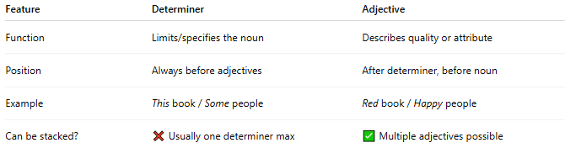
Feature | Determiner | Adjective
Function | Limits/specifies the noun | Describes quality or attribute
Position | Always before adjectives | After determiner, before noun
Example | This book / Some people | Red book / Happy people
Can be stacked? | ❌ Usually one determiner max | ✅ Multiple adjectives possible

📝 Summary:
# Source: AI Source: Provided by: [Data Path: Persons Table -> ID Column: 1, Name_En Column: Motasem Essam] -> From: [Chatgpt (GPT-4-turbo)] on [8/3/2025]
- The determiner function is to modify nouns in terms of reference, quantity, or definiteness.
- Determiners introduce noun phrases and limit their meaning.
- Common types: articles, demonstratives, quantifiers, possessives, etc.
- Functionally, determiners anchor or frame the noun, while adjectives describe it.

